Welcome Controller Requirements Spec2

Image3.png

Dolly

# Image0.png Welcome Controller

## Scenarios

| Scenario |
| --- |
| 1. displayWelcome() Image1.pngWelcome View |
| 2. (listener) welcomeView.startButton(&welcomeViewData) == pressed |
| 3. end |
| Extension: |
| 2.a. set welcome data in Image1.pngChess Game Model |
| 1. player1.setName(welcomeViewData.player1) |
| 2. player2.setName(welcomeViewData.player2) |
| 3. turn.setTurn(welcomeViewData.turn) |
| #.a. |

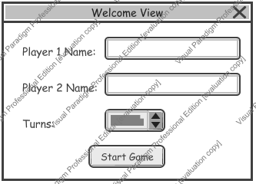

1. displayWelcome() Welcome View